Project 1: Deploying a Highly Available Web Application and Bastion Host in AWS

|  |  |
| --- | --- |
| Step 1 | Create a VPC with a Public & Private Subnet |
| Step 2 | Create Internet gateway and associate with the Public Subnet |
| Step 3 | Creating NAT Gateway & associate with Private Subnet |
| Step 4 | Launch Bastion Host in Public Subnet |
| Step 5 | Creating a Security Group for the Load Balancer |
| Step 6 | Launch two Web Servers securely in Private Subnet |
| Step 7 | SSH into Web Servers through Bastion Server using RSA private key, Install Apache, Host Page(index.html) on Web Servers |
| Step 8 | Creating additional Public Subnets, each in different availability zone and in same VPC |
| Step 9 | Creating an Application Load Balancer with multiple subnets |
| Step 10 | Checking the health of Load Balancer & Testing DNS |
| Step 11 | Testing High Availability |

STEP 1 : Create a VPC with a Public & Private Subnet

* Log into AWS Management Console
* Click on Services and Search for VPC
* Select VPC & do following tasks

Task 1 : Create VPC

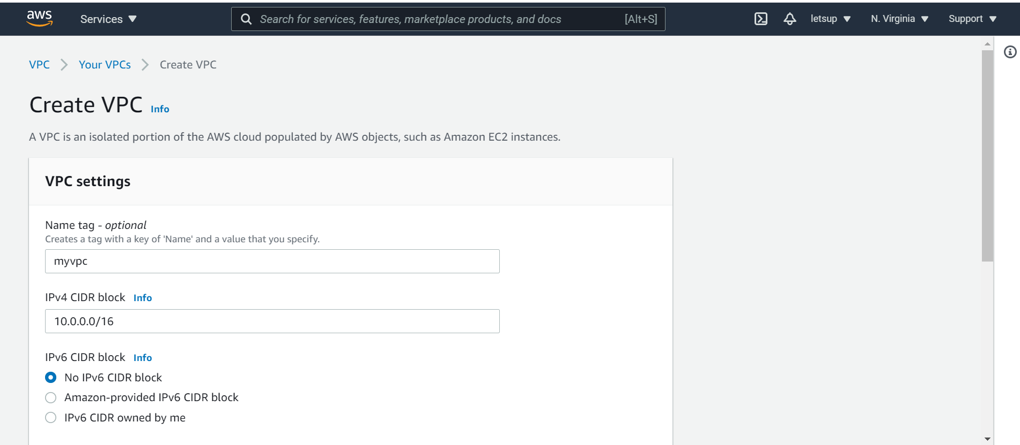

* + Name tag : myvpc
  + IPv4 CIDR block : 10.0.0.0/16
  + IPv6 CIDR block : No IPv6 CIDR block
  + Tenancy : Default
  + Click on Create VPC

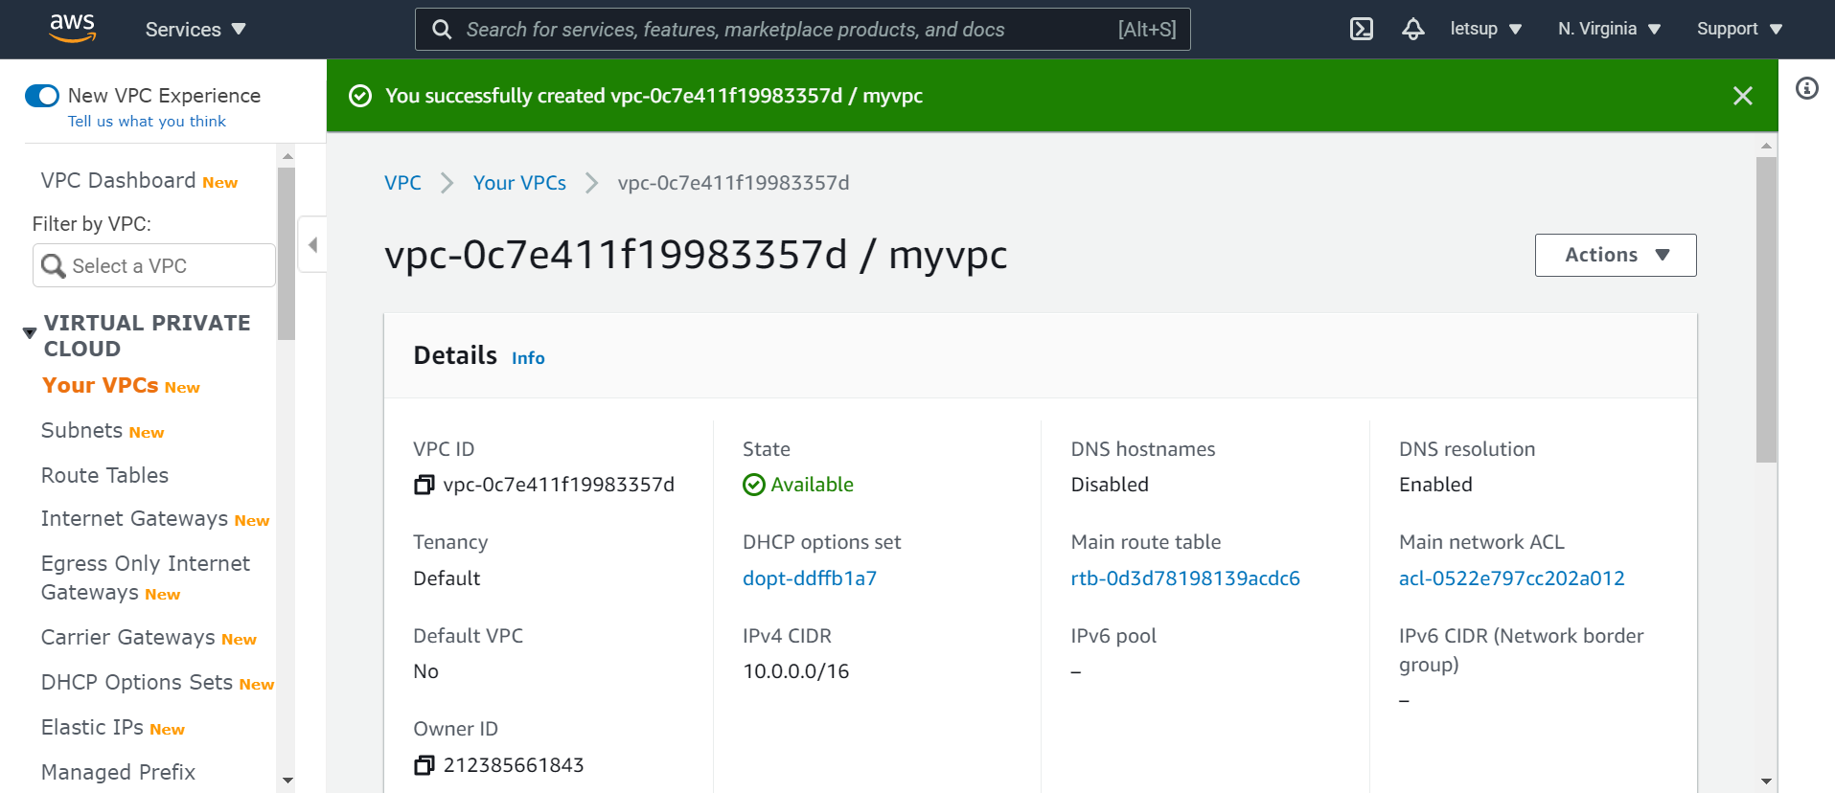

Task 2 : Create Public & Private Subnet

1. Go to Subnets in the left panel of the VPC page
2. Creating Public Subnet, Click on Create subnet

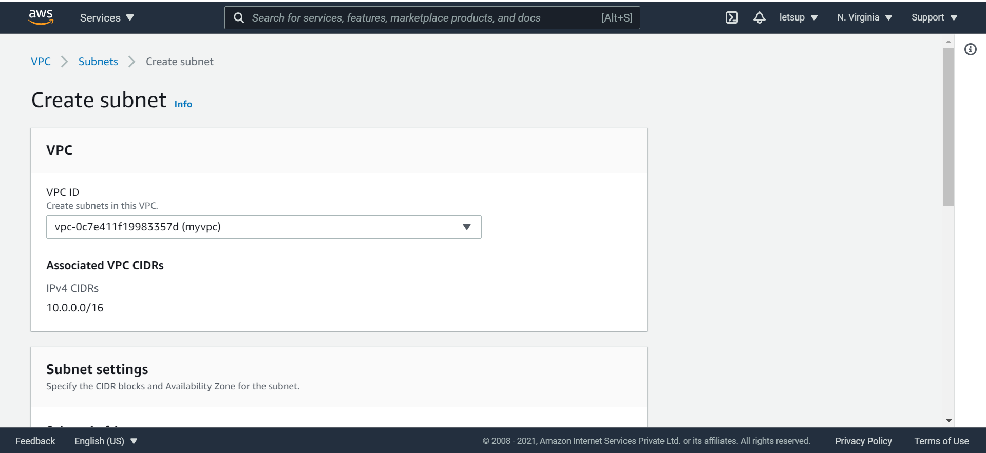

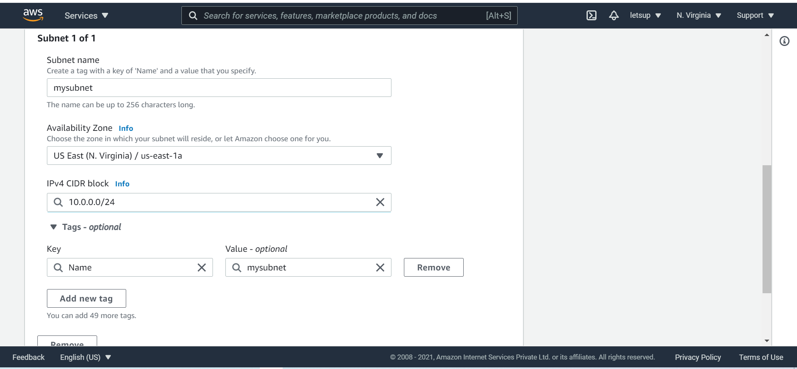

* Name tag : mysubnet
* VPC : Select myvpc
* Availability Zone : us-east-1a
* IPv4 CIDR block : 10.0.0.0/24
* Click on Create
* 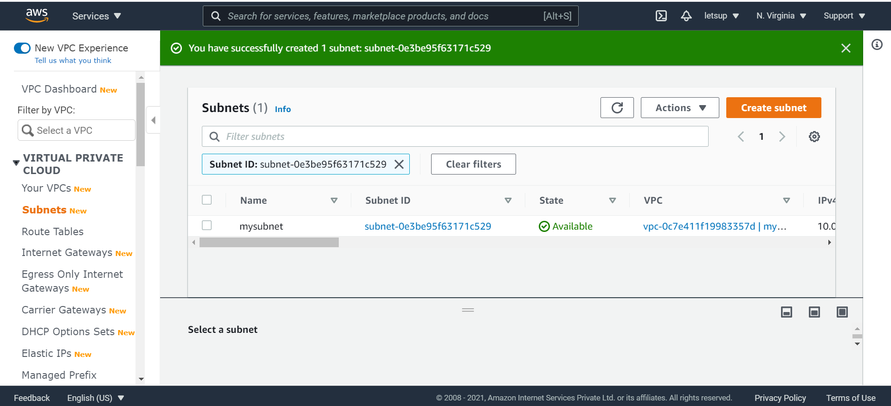3. Enable Auto Assign Public IP to instances created within this subnet
* Click on Modify auto-assign IP settings

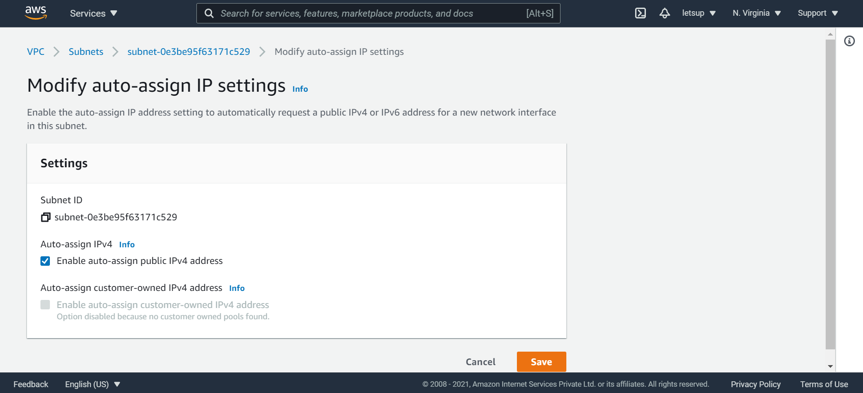

1. Create Private subnet, Click on Create Subnet

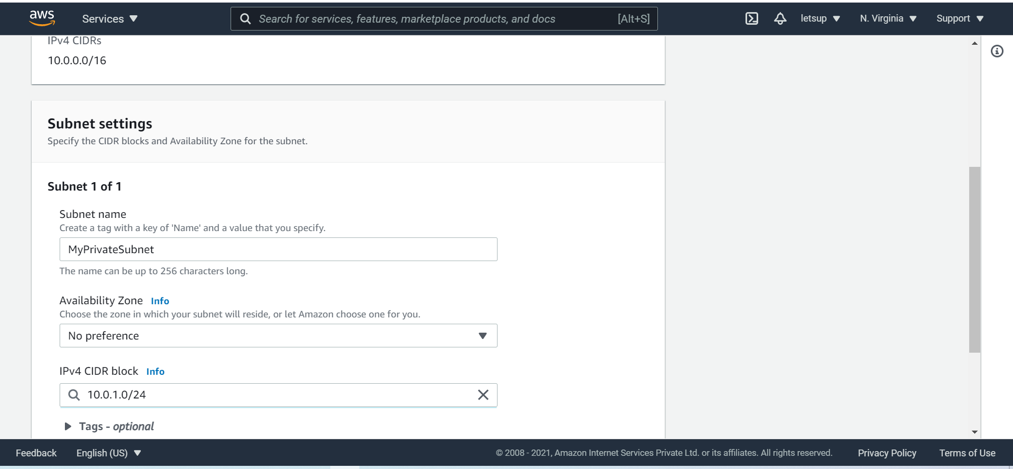

* Name tag: MyPrivateSubnet
* PC : Select myvpc
* Availability Zone : No preference
* IPv4 CIDR block : 10.0.1.0/24
* Click on Create

You will see two subnets created (Public & Private).

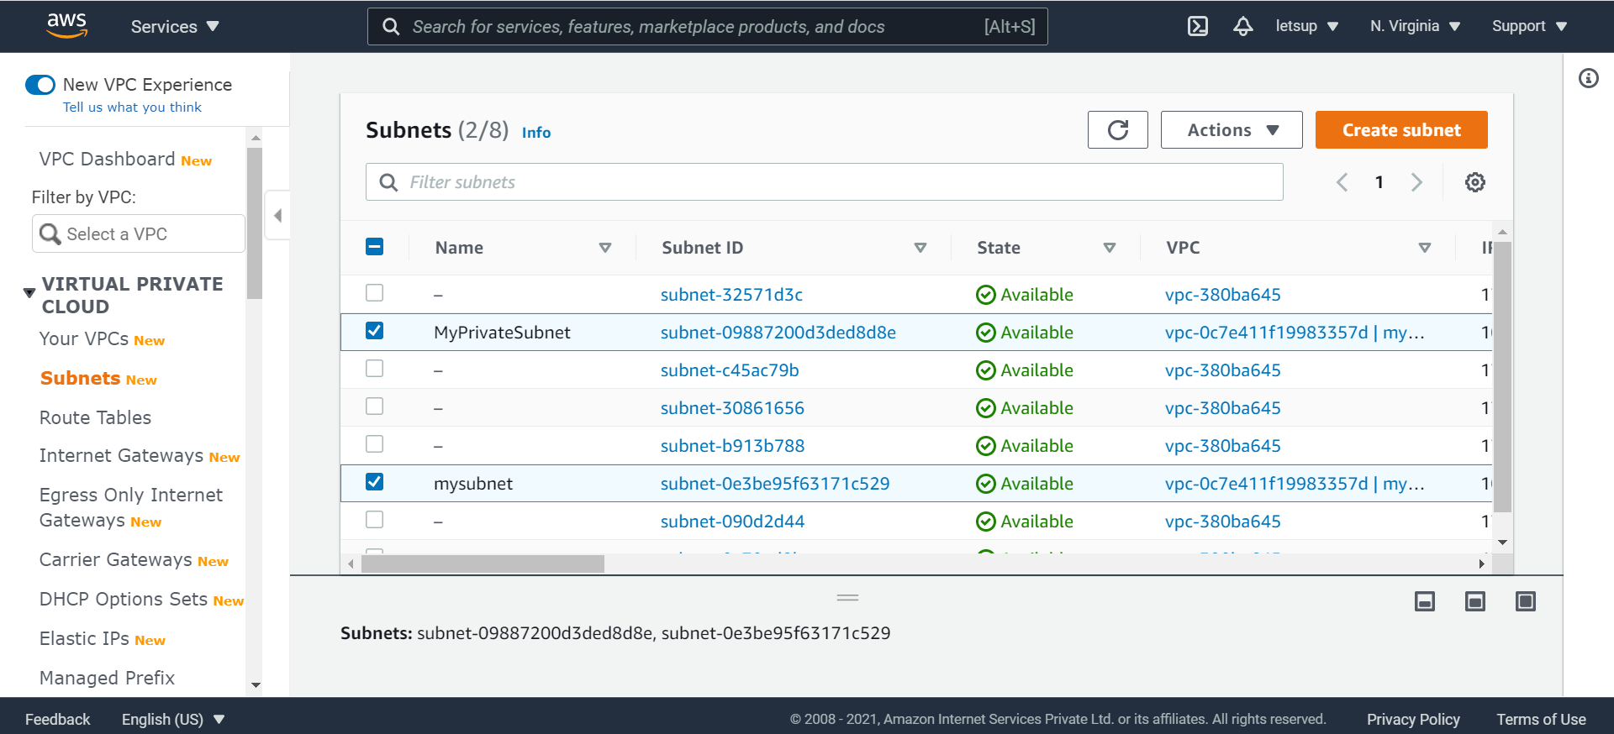

STEP 2 : Create Internet Gateway & associate with Public Subnet

An internet gateway is a virtual router that connects VPC to the internet.

1. Go to Internet Gateways in the left panel of VPC page
2. Click on Create Internet Gateway
3. To create new internet gateway specify the name for the gateway below

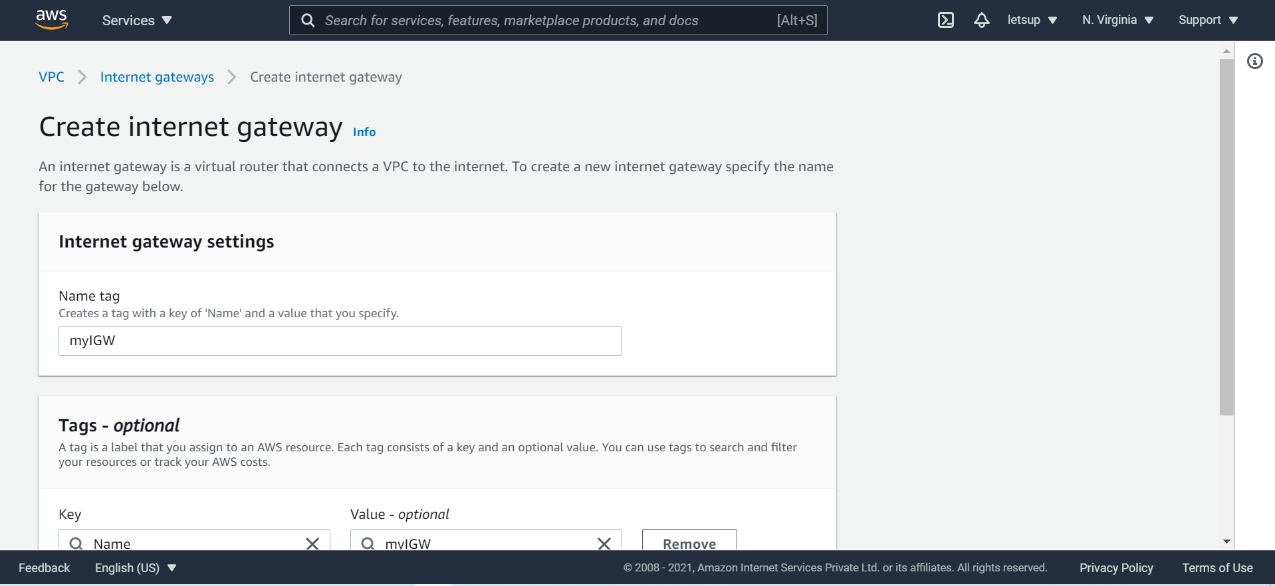

* + Name : myIGW
  + Click on Create internet gateway
  + Click on Attach to a VPC at the top

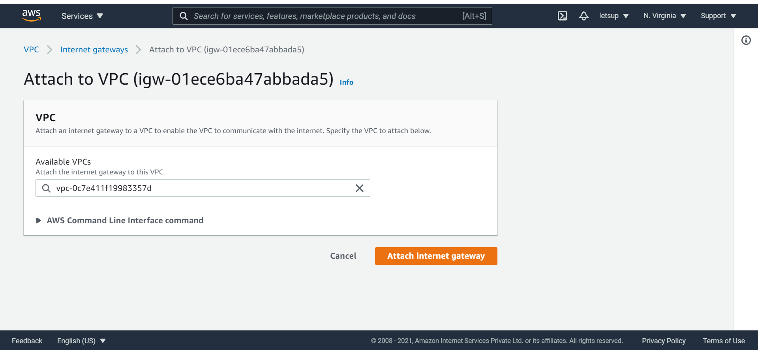

* Select MyVPC
* Click on Attach internet gateway

You can see the internet gateway (MyIGW ) is attached to VPC (MyVPC)

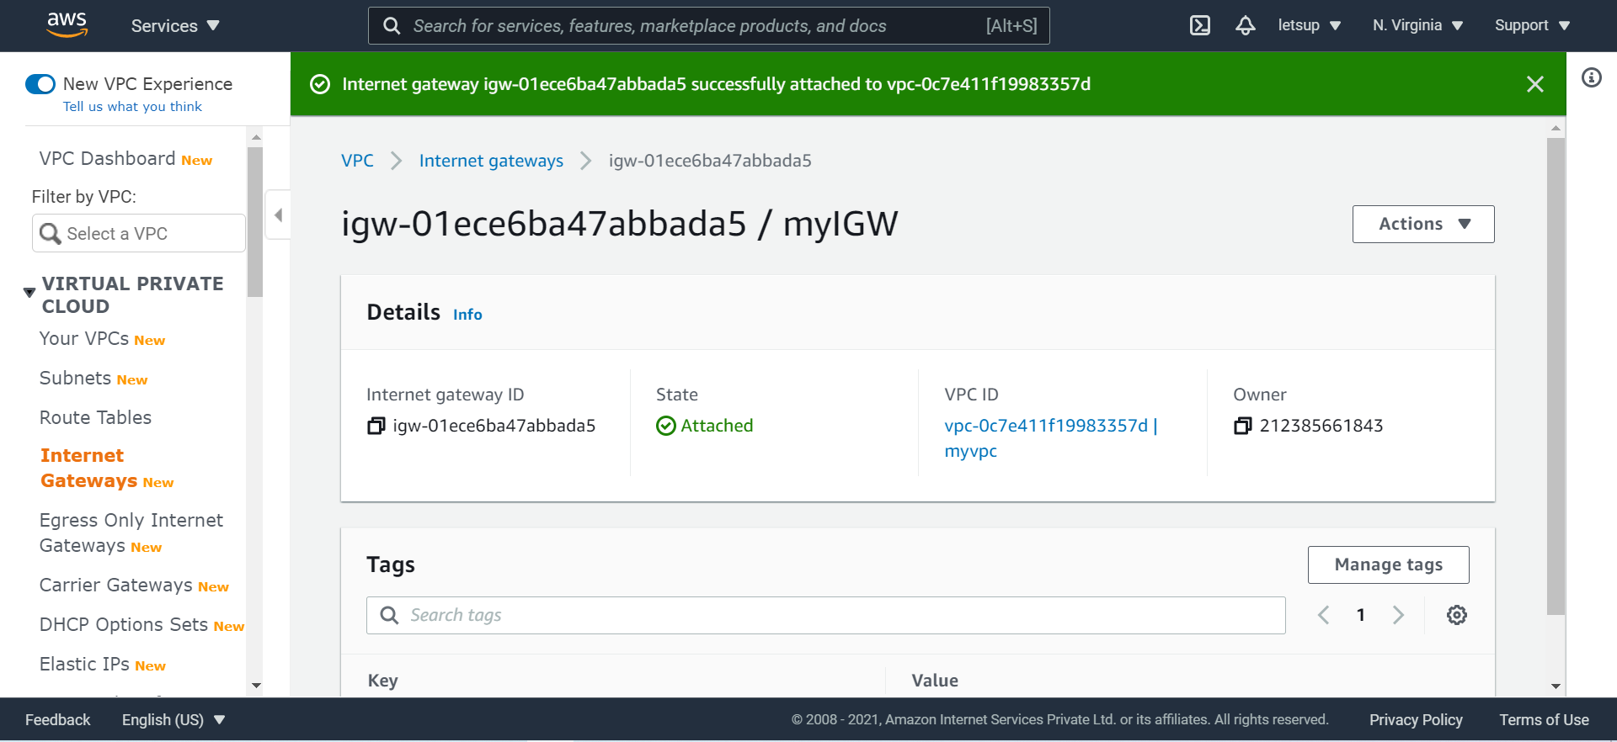

Task 4 : Create Public Route Table and Configure

We will create a route table and attach a public subnet to it. Instances launched within this subnet will have access to the Internet.

1. Go to **Route Tables** in the left panel of the VPC page

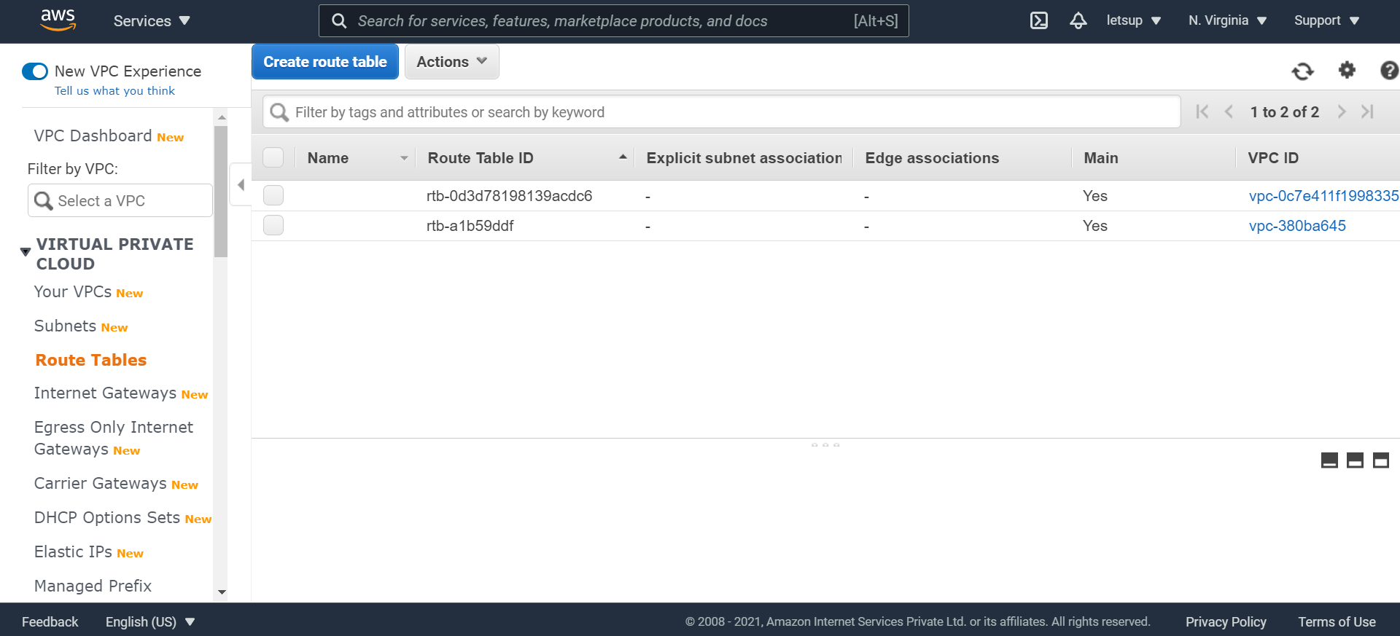

1. Click on **Create route table**

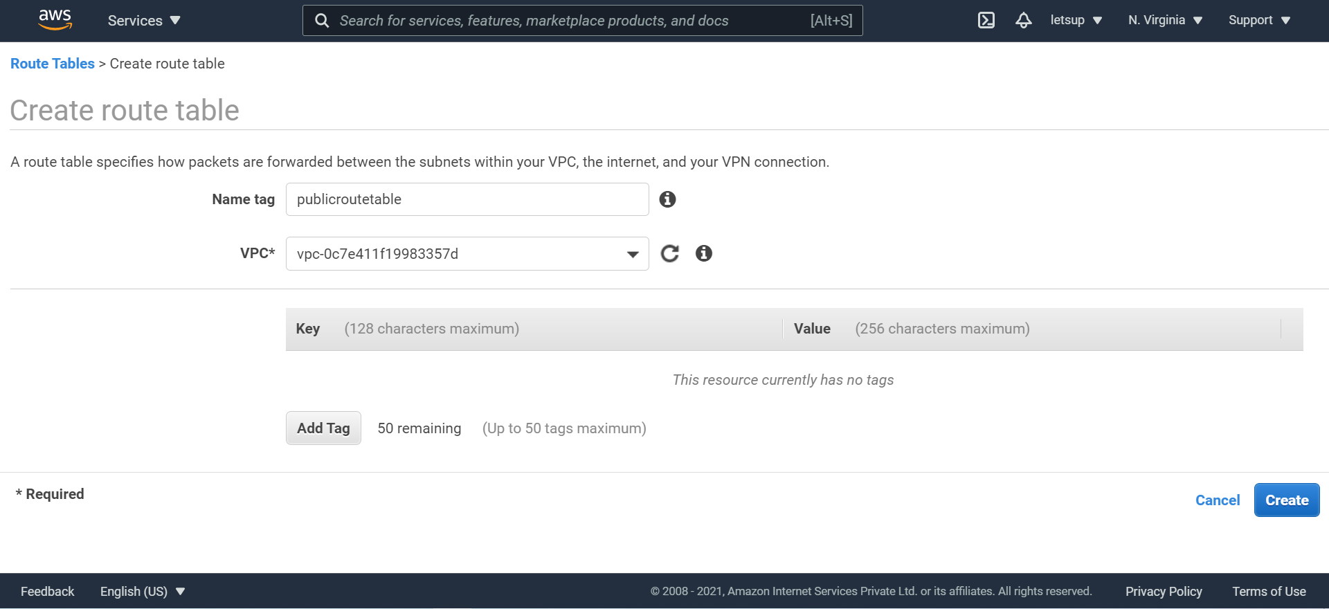

* + Name tag : **publicroutetable**
  + VPC : Select **myvpc**
  + Click on **Create**

You will get a message Route Table was created click on Close.

1. To attach Internet Gateway, select PublicRouteTable

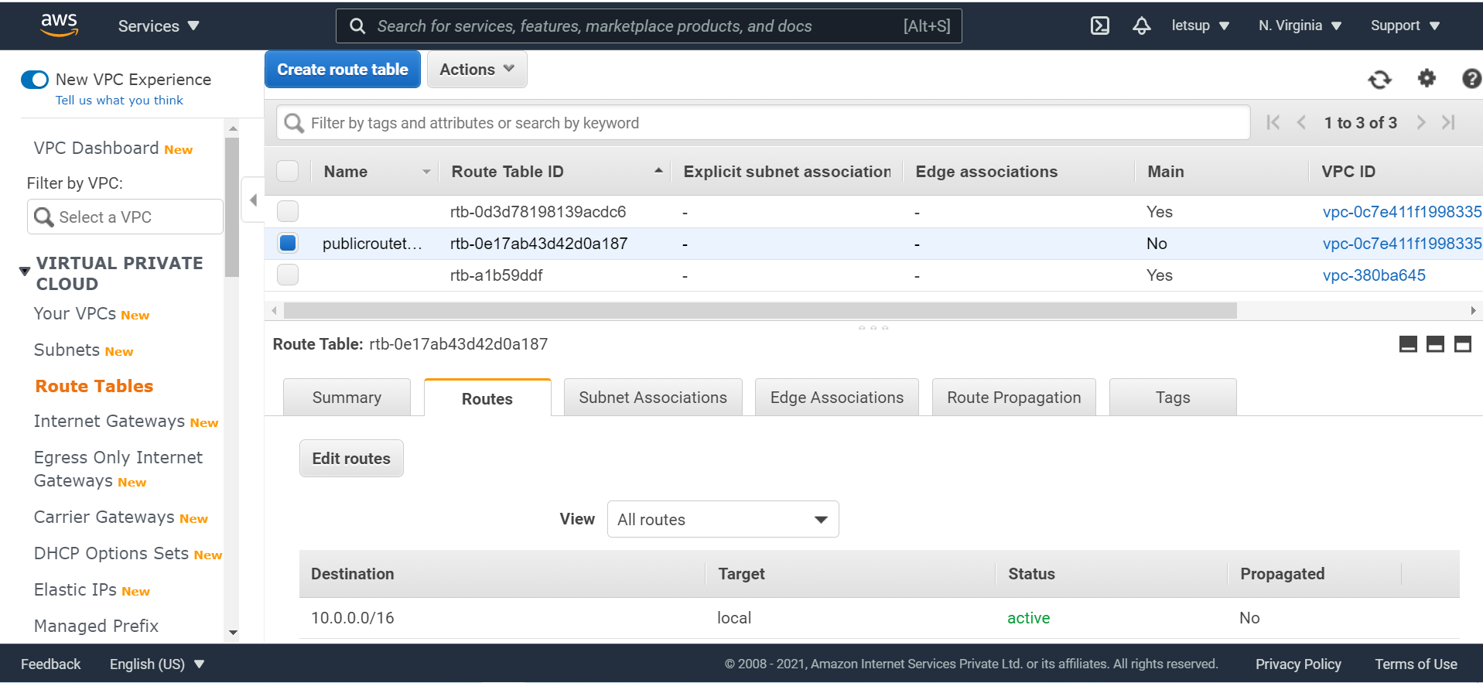

1. In the Routes tab, Click on Edit routes
2. On the next screen click on Add route

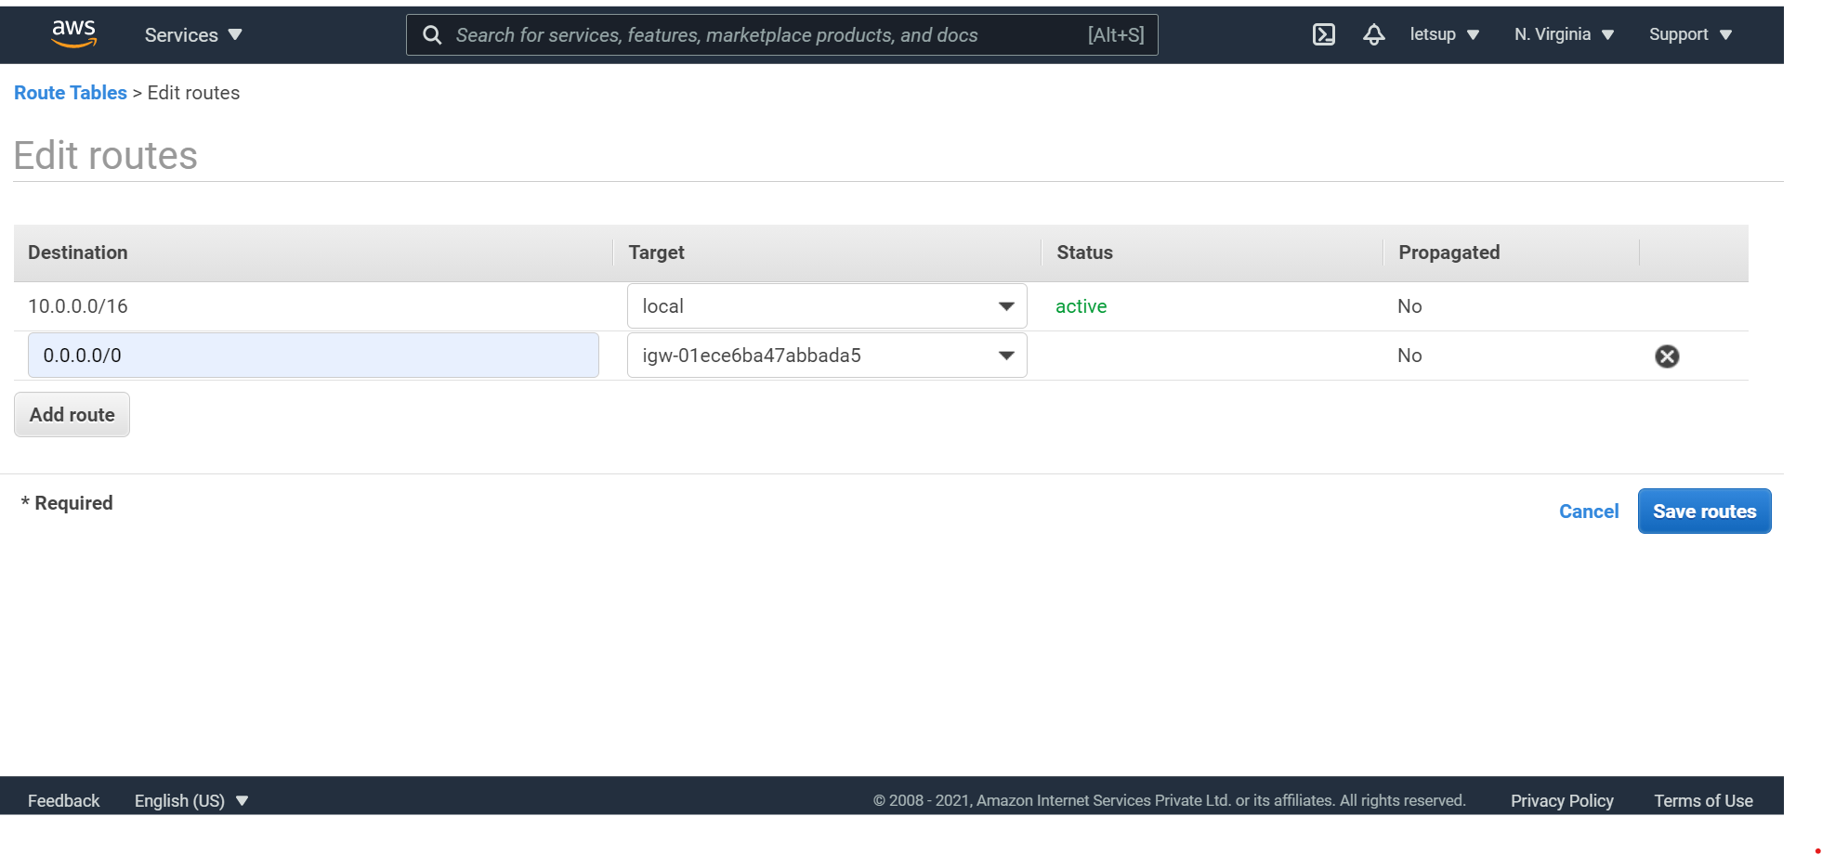

* + Destination : Enter 0.0.0.0/0
  + Target : Select Internet Gateway, and then from the list select myIGW
  + Click on Save routes
* Select the route table : PublicRouteTable

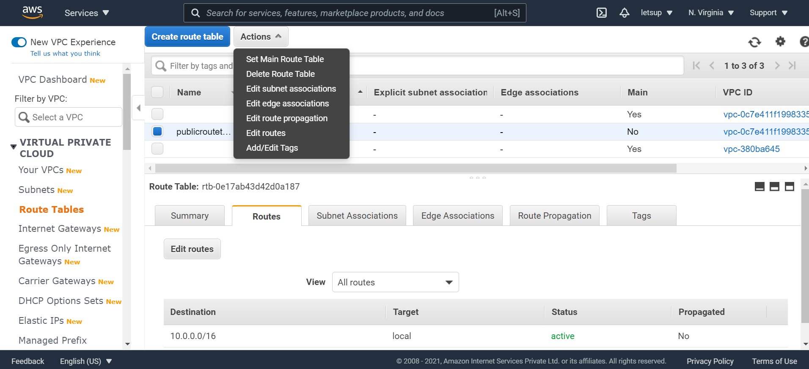

* Click on Actions & select Edit subnet associations
* On the next screen, select mysubnet

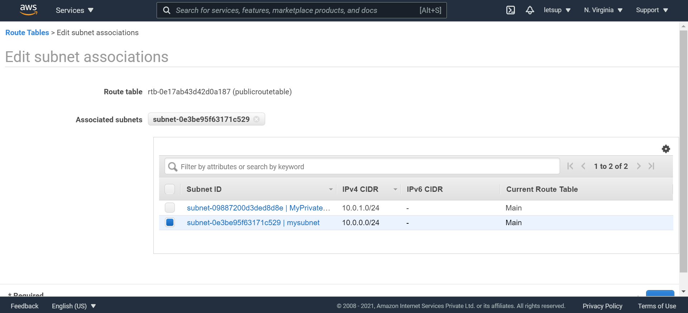

* Click on Save

Once the configurations are completed, it will should look like below :

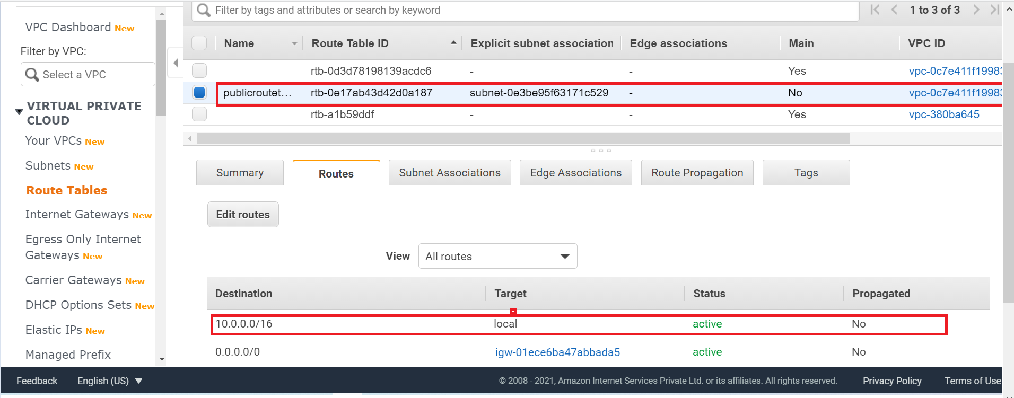

Step 3 : Creating NAT Gateway & associate with Private Subnet

Task 1 : Create NAT Gateway

1. Create NAT gateway :

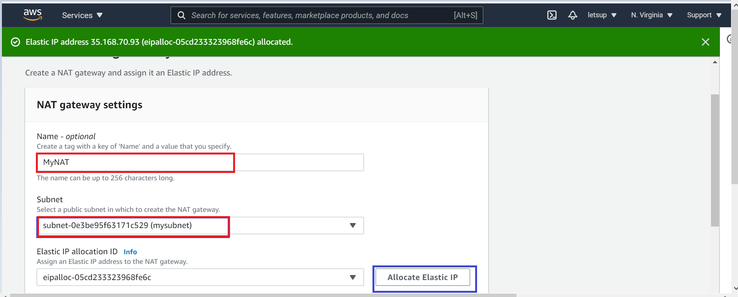

* + Name : MyNAT
  + Subnet : Select mysubnet
  + Elastic IP allocation ID : Click on Allocate Elastic IP An elastic ip is allocated to the NAT gateway.
  + Click on Create NAT gateway.

1. We will see the NAT gateway is created.

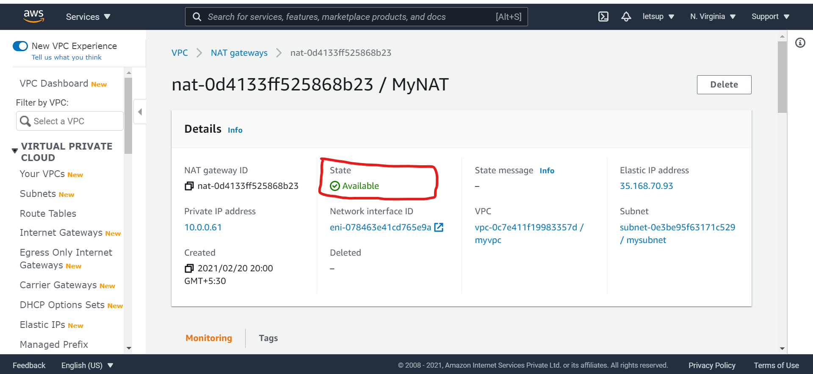

Task 2 : Update Route Table and Configure NAT Gateway

1. Go to Route Tables in the left panel.

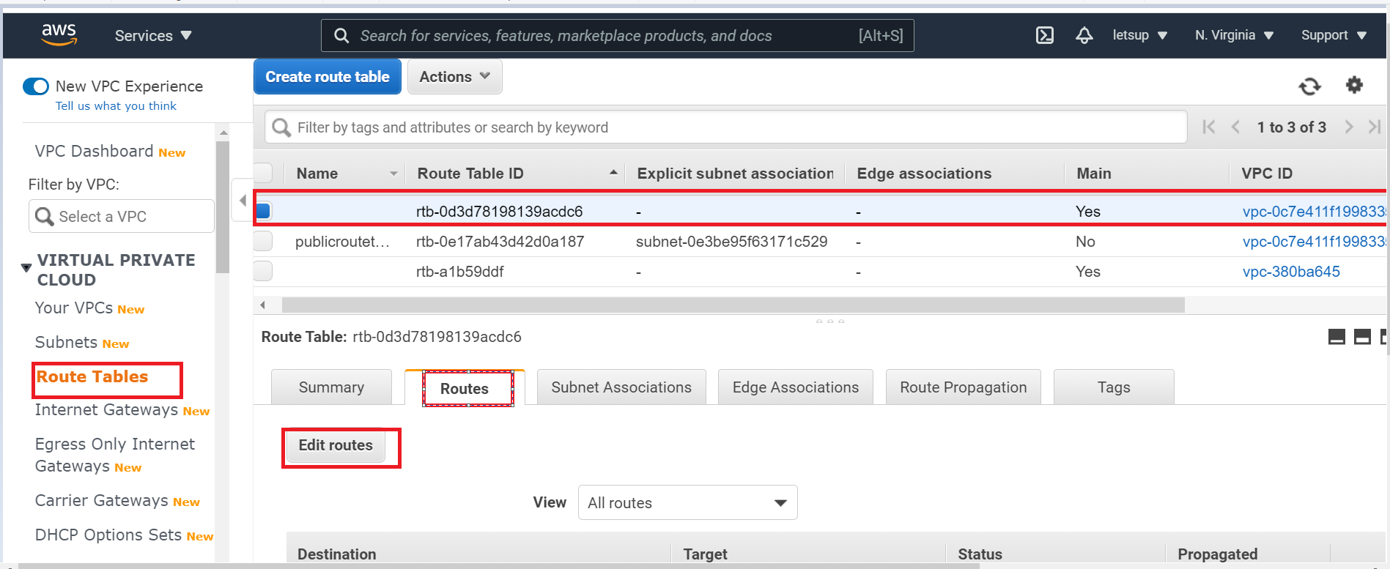

1. You can see two route tables available for myvpc
2. Select the Main route table (*Main : Yes*)
3. In Routes tab click on Edit Routes
4. In next page Edit Routes :

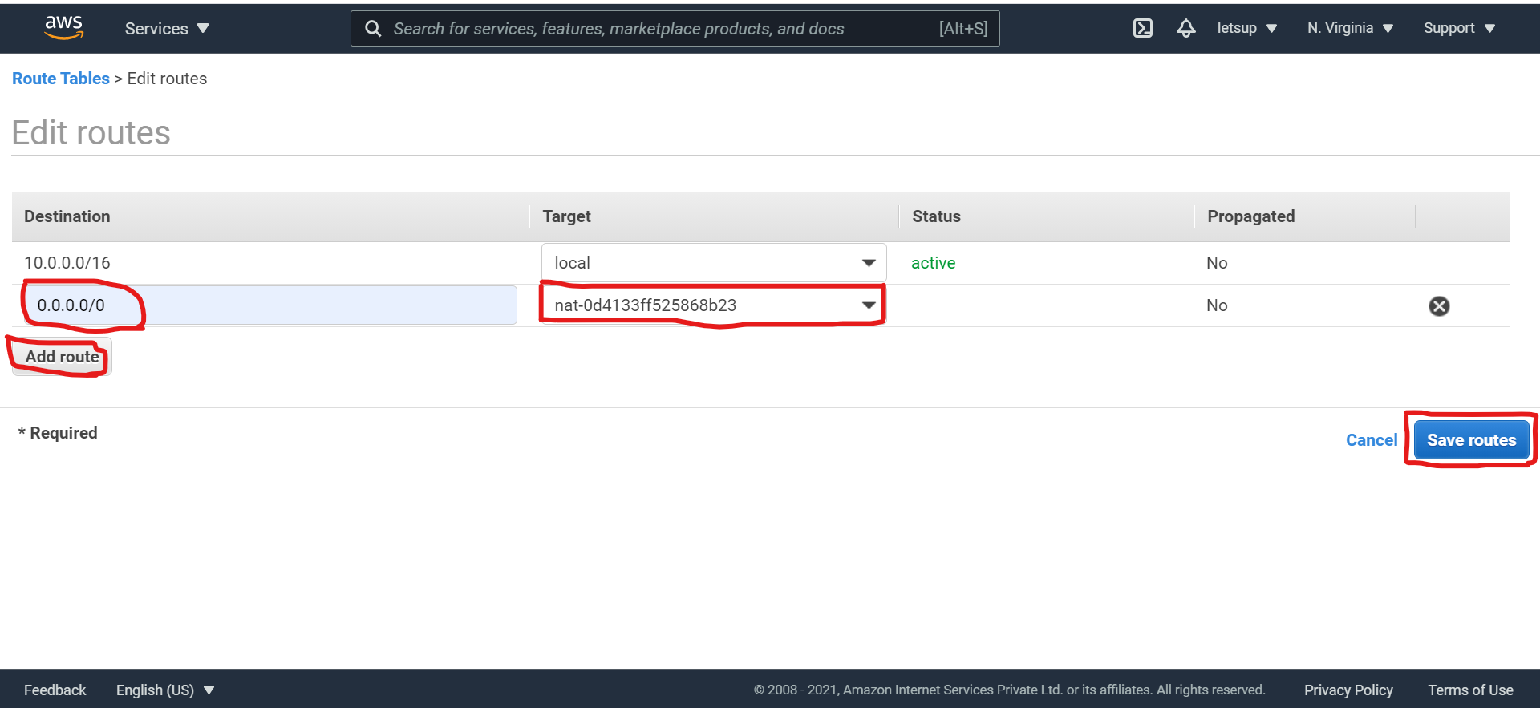

* + Destination : Enter 0.0.0.0/0
  + Target : Select NAT Gateway, then select MyNAT
  + Click on Save routes

1. You will get a message “Routes successfully edited”. Click on Close.
2. NAT Gateway is configured. In Routes tab, Check the NAT Gateway is active.

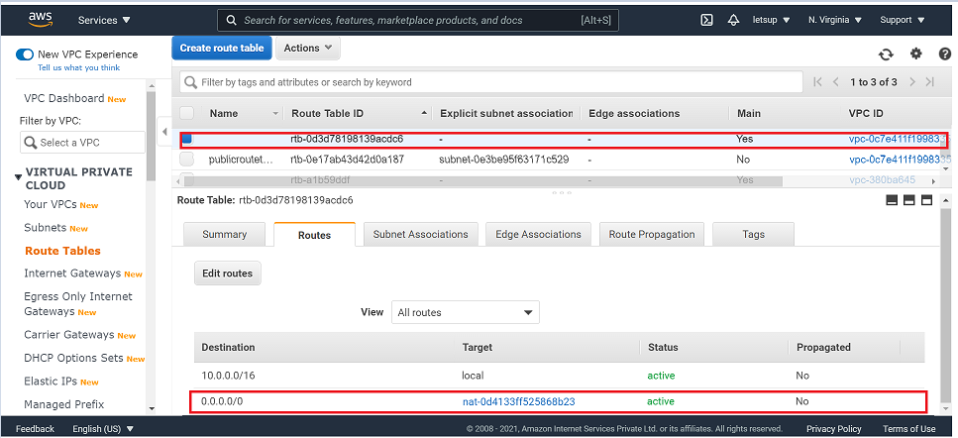

Step 4 Launch Bastion Host in Public Subnet

Bastion Host is a computer that acts like a proxy server that allows the client machine to connect to the remote server. It filters the incoming traffic and prevents unwanted connections entering the network.

1. Add Tags : Click on Add Tag

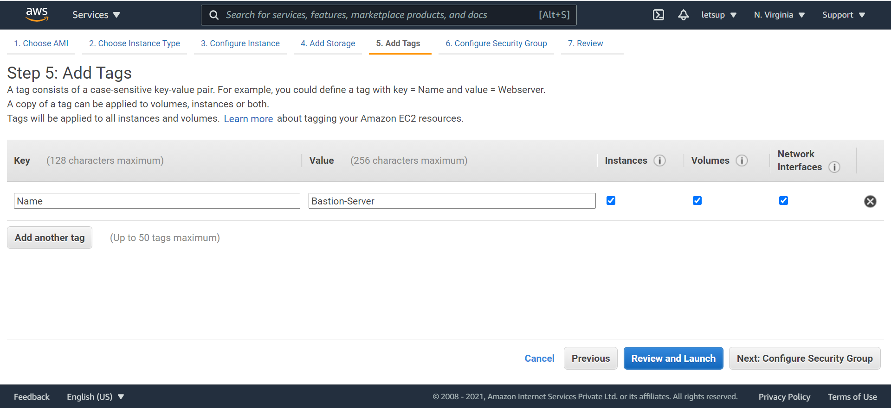

1. Configure Security Group :
   * Assign a security group – Select Create a new security group

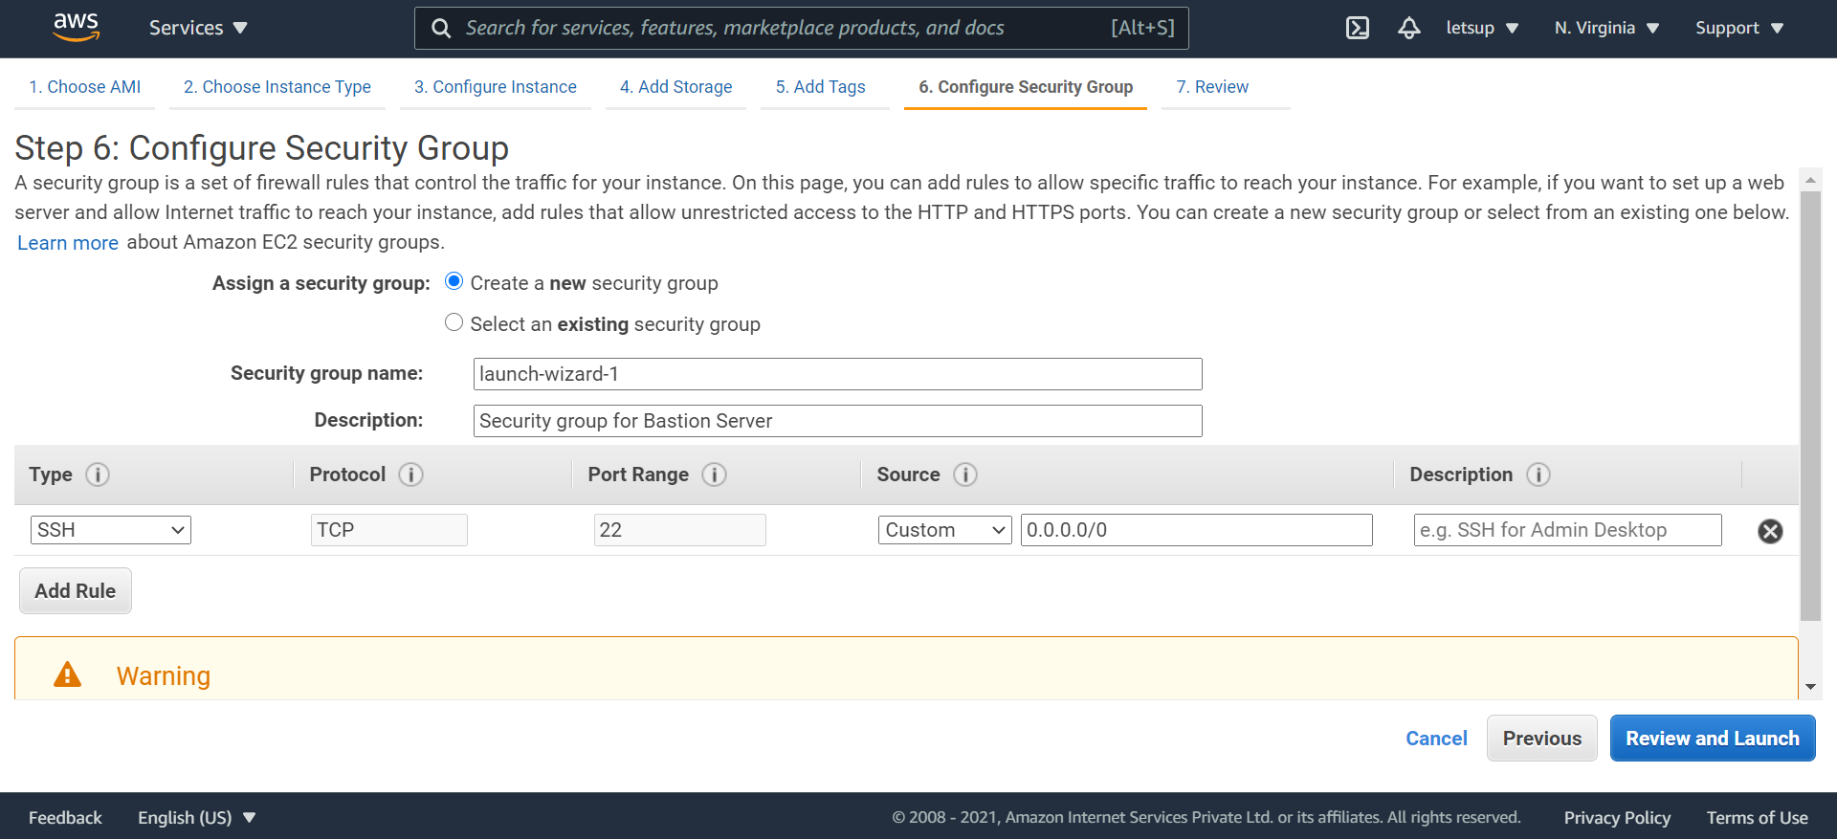

* + Security Group Name : launch-wizard-1
  + Description : Security group for Bastion Server
  + Make sure you select type : SSH (*will be default selected*)
  + Source : Custom – 0.0.0.0/0
  + Click on Review and Launch

1. Review Instance Launch : Review all the settings

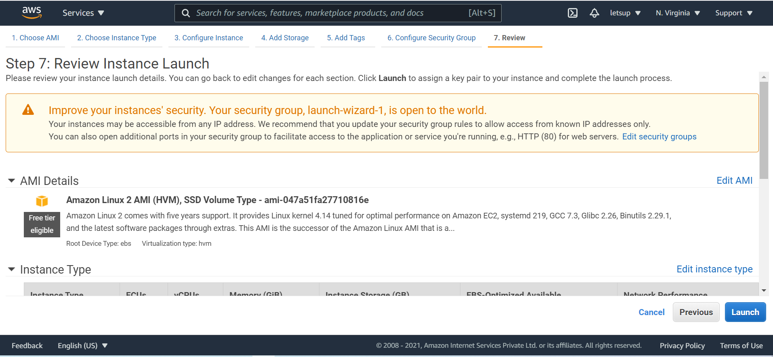

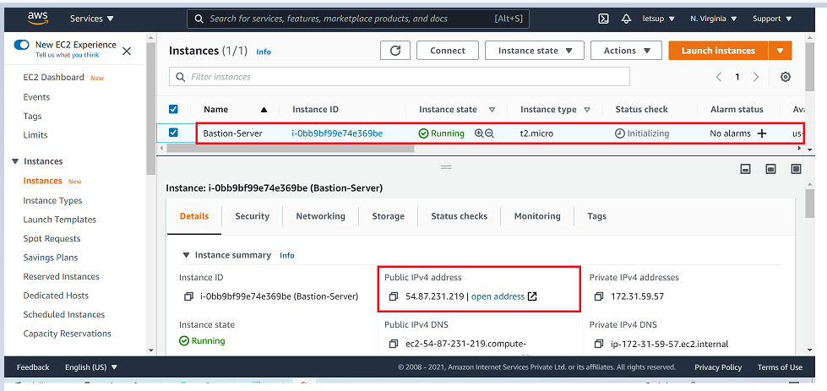

* + Bastion Host Associated Public IP : 54.87.231.219

Step 5 Creating a Security Group for the Load Balancer

1. On the EC2 Dashboard, Scroll down the left panel and Select Security Groups

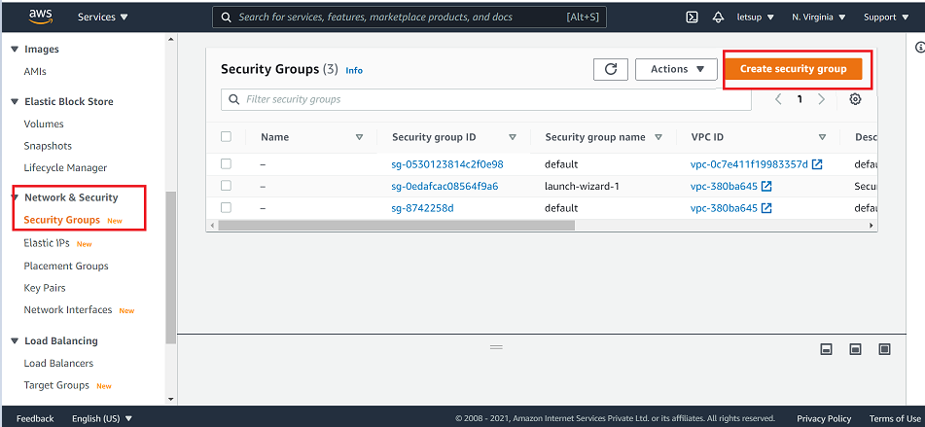

1. Click on Create security group

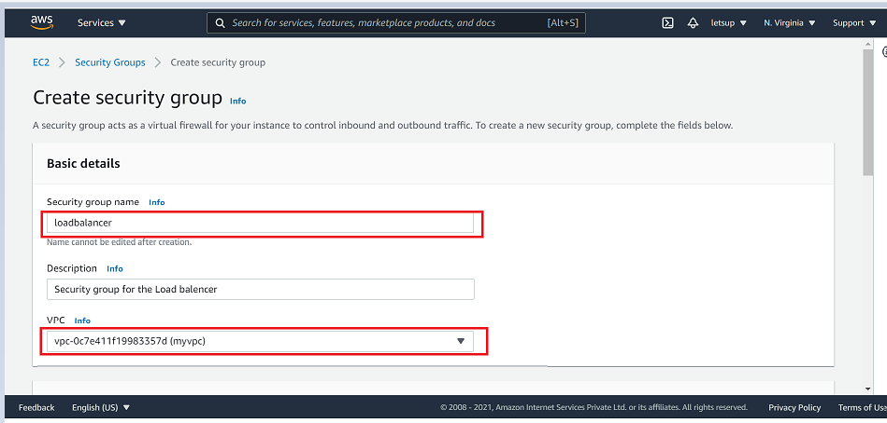

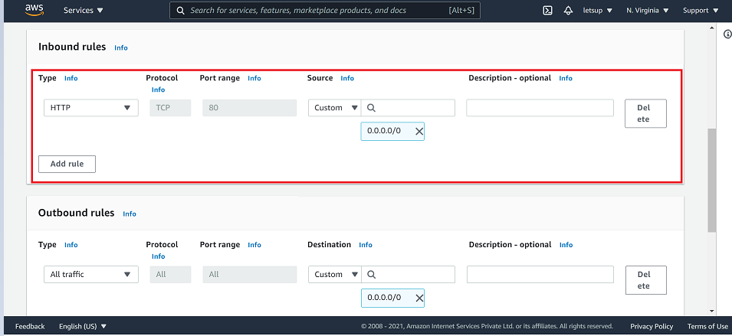

* + Security Group Name : loadbalancer-SG
  + Description : Security group for the Load balancer
  + VPC : myvpc
  + Inbound rules :
    - Click on Add rule
    - Type : Select HTTP, make sure Protocol is TCP and Port range is 80
  + Source : Custom and select 0.0.0.0/0
  + Outbound rules : Leave as default
  + Tags-optional : Leave as default
  + Click on Create security group

1. The security group for the load balancer will be created

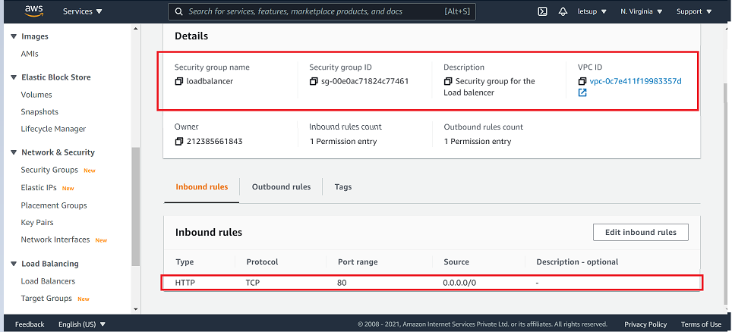

* Check the Inbound rules with added HTTP rule

Step 6- Launch two Web Servers securely in Private Subnet

We have created a private subnet and NAT gateway. The private subnet is attached to a route table to route traffic via NAT gateway to the internet. Now let us create two webservers in private subnet.

Task 1 : Launching Web Server 1

1. Make sure you have selected N. Virginia region
2. Click on Services on the top and search for EC2 & select it

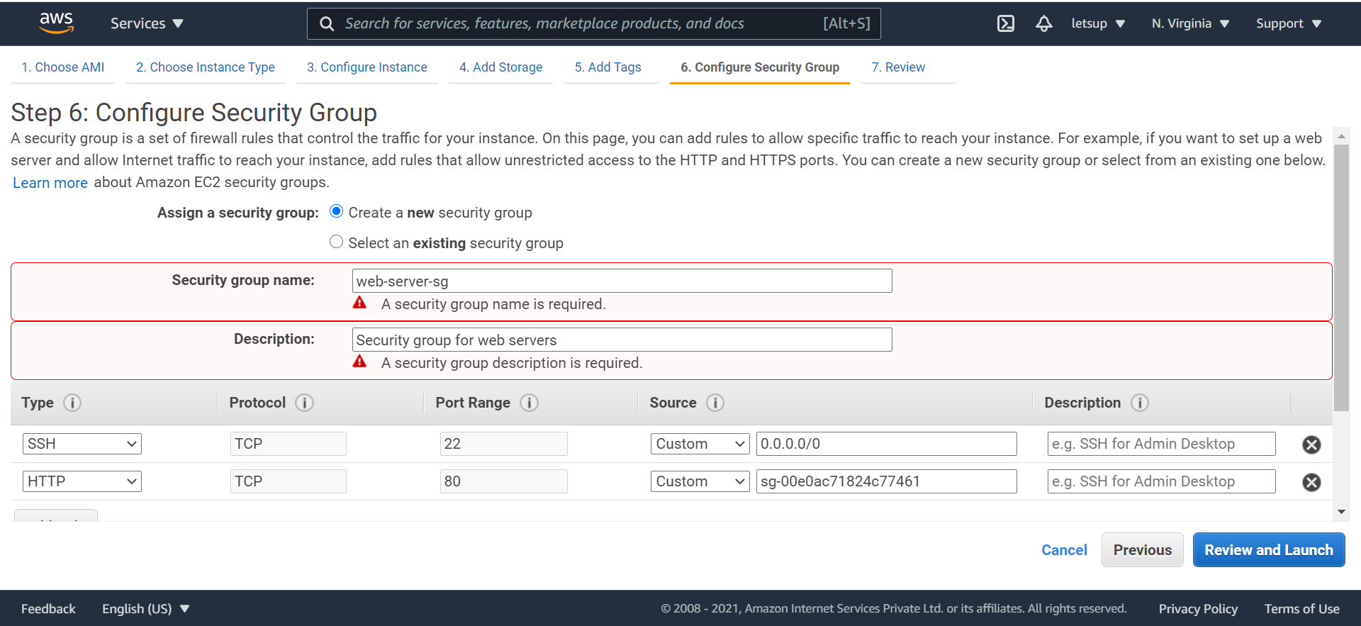

* + Security Group Name : web-server-sg
  + Description : Security group for web servers
  + Make sure you select Type : SSH (*will be default selected*)
  + Source : Custom – type Bastion and select Bastion-SG

1. Web-server-1 Details : You will see new instances Web-server-1 running along with Bastion-server created in the earlier step.

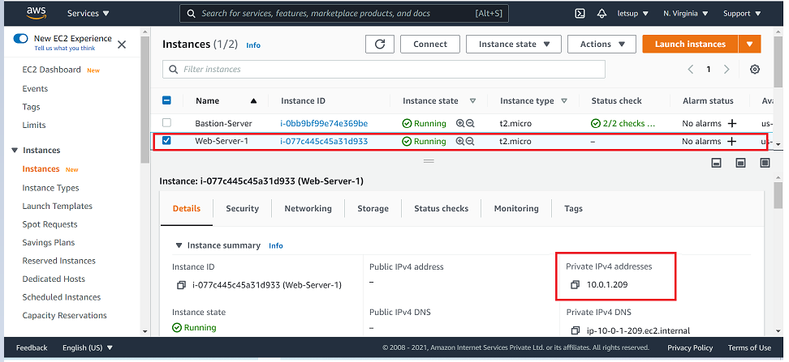

Task 2 : Launching Web Server 2

Step 6 : Configure Security Group section, select existing group web-server-sg

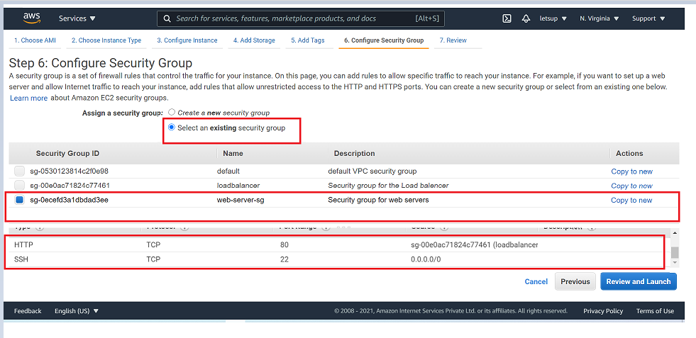

Step 7 - Click on Review and Launch and then Click on Launch and select a key pair, MyKey.pem, and Launch the instance.

1. Now you will see three servers running namely :
   * Bastion-server,
   * Web-server-1
   * Web-server-2

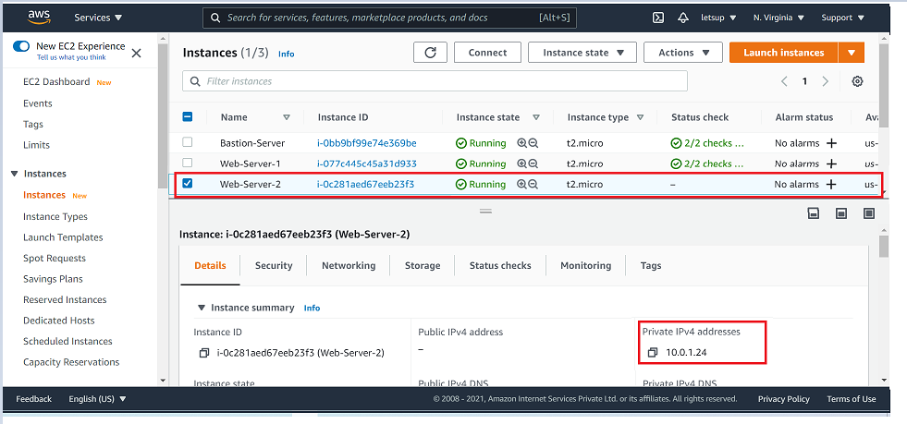

1. Web-server-1 Private IP : 10.0.1.209
2. Web-server-2 Private IP : 10.0.1.24

Step 7 : SSH into Web Servers through Bastion Server using RSA private key, Install Apache, Host Page(index.html) on both Web Servers

Task 1 : Connecting to Bastion-Server

1. Go To EC2 Dashboard & Click on Instances

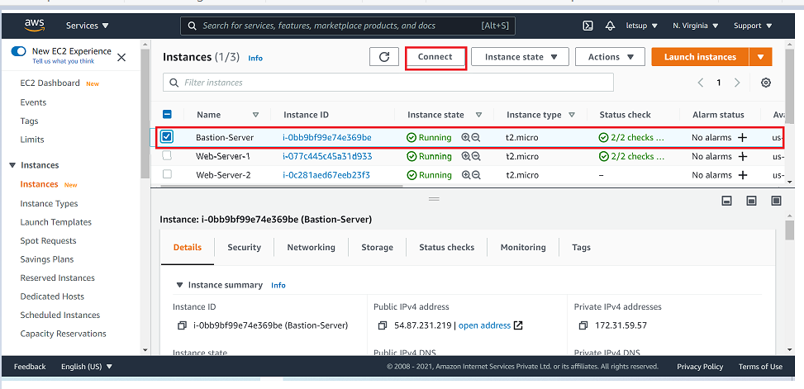

1. From the list of instances, select Bastion-Server and click on Connect.
2. Connect the instance through EC2 Instance Connect.

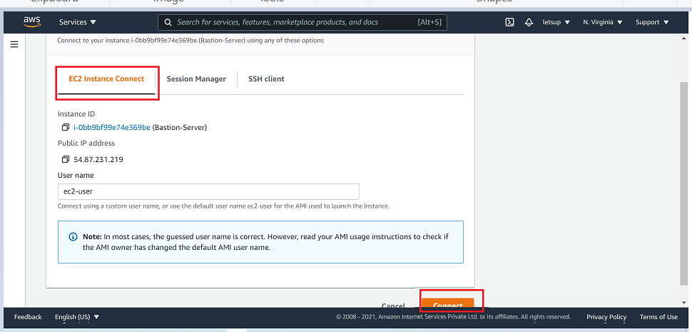

1. Click on Connect.
2. You will be connected to the server
3. Type : sudo su – You will be switched to super/root user

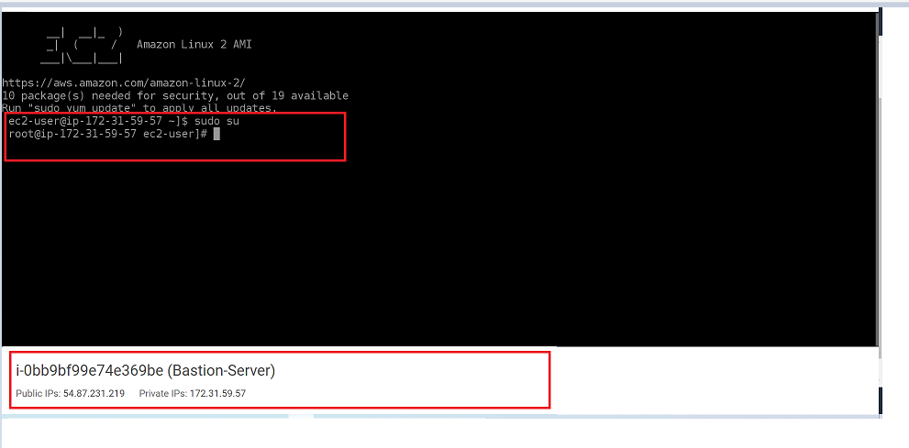

Task 2 : Connect Web-servers through Bastion-Server

1. To connect to the web servers via Bastion-server, we will need the web server key which we used to launch the web servers.(mykey.pem)
2. Open the mykey.pem file on your local system and copy it’s content.

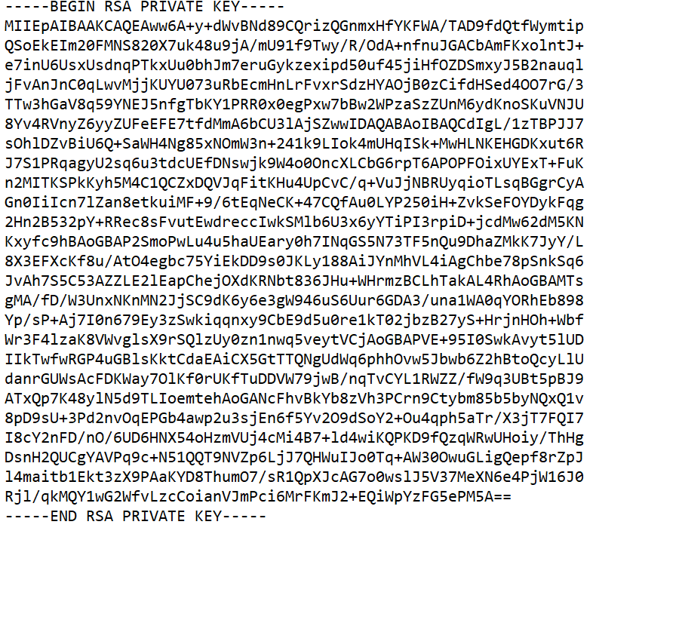

1. Go to the Bastion-server which we have connected and create a file named web-serverkey.pem. Below is the command :
   * vi web-serverkey.pem

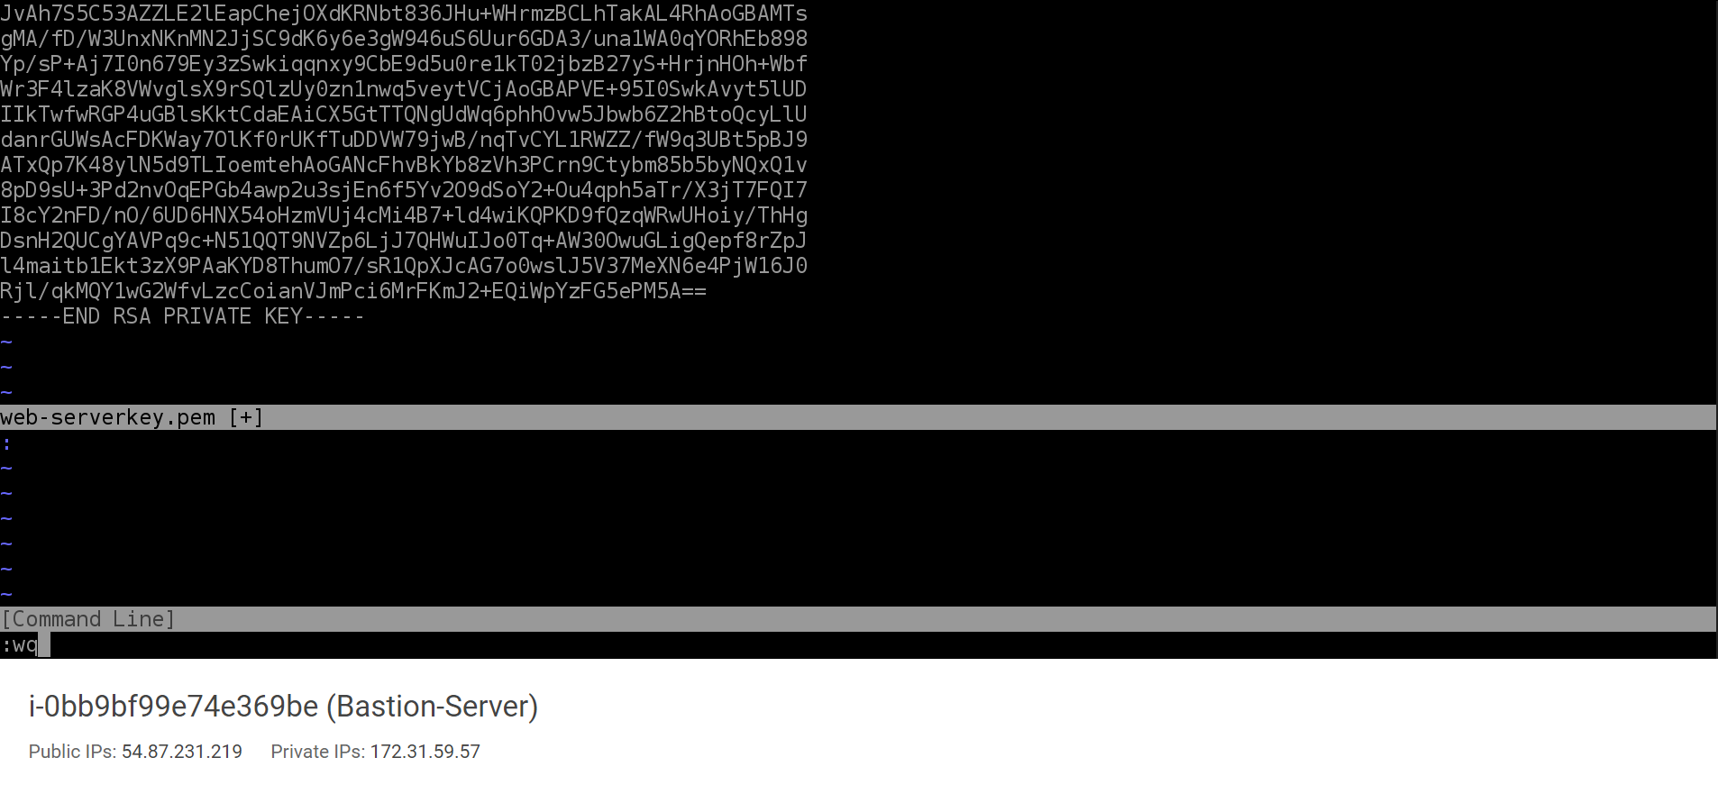

* + press i & paste the content that you have copied from mykey.pem here.
  + Press Esc key & type :wq & press enter.

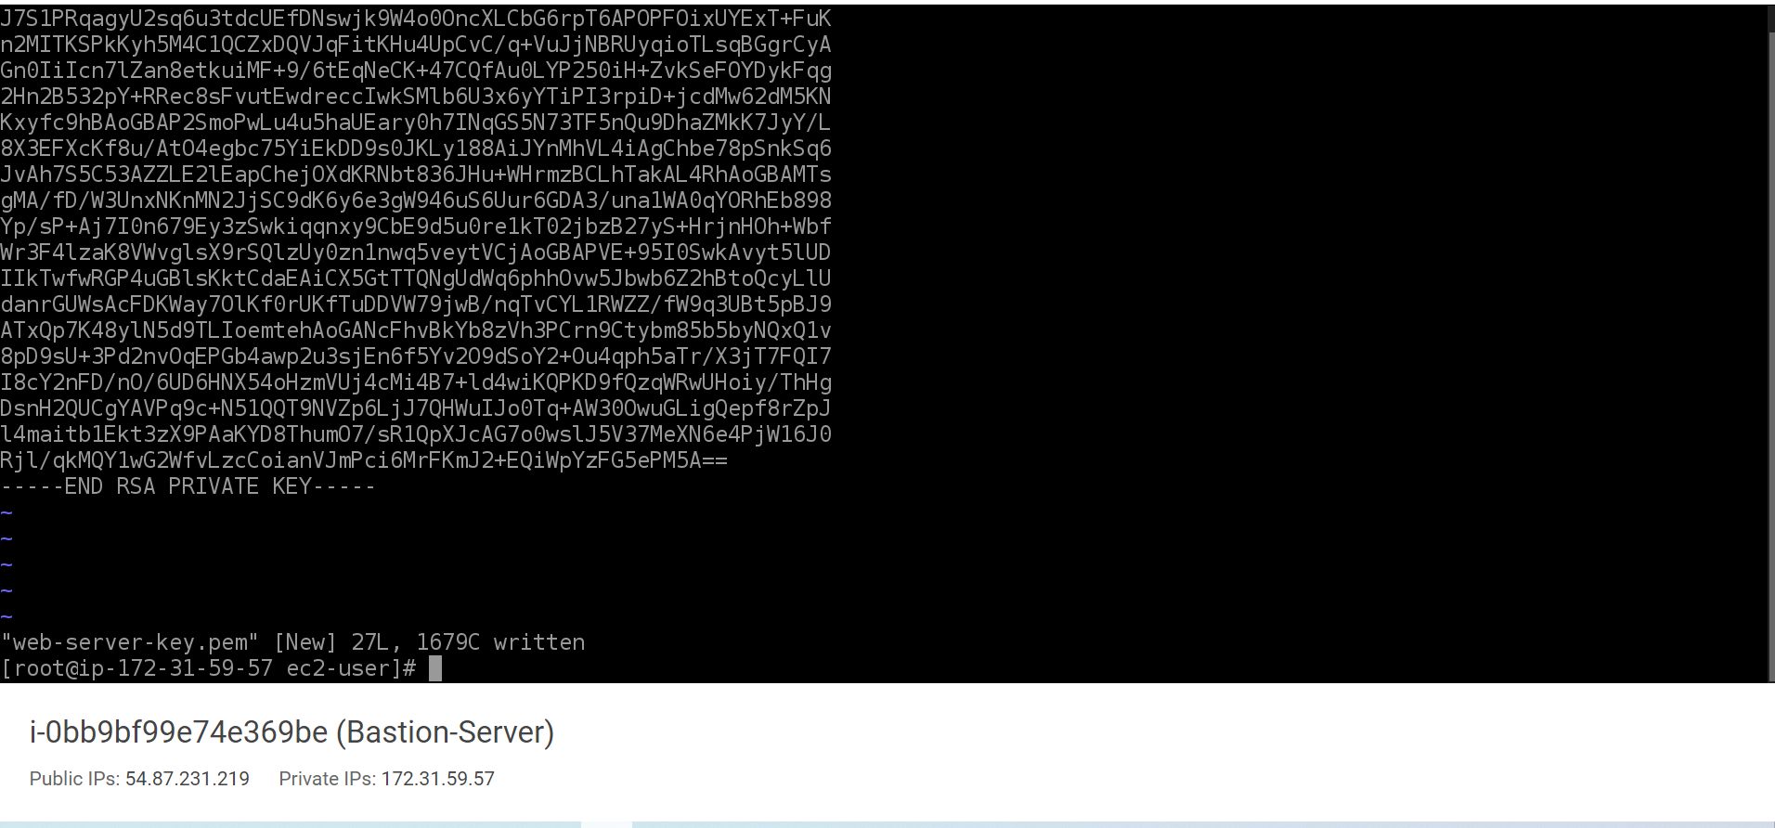

* + A file with web-server-key.pem will be created

1. Now we will have to change the permission of the pem file. Below is the command :
   * chmod 400 web-server-key.pem
   * This command will give read-only permission to file.
2. Now we can connect/login to the web servers using
3. Click on Create subnet

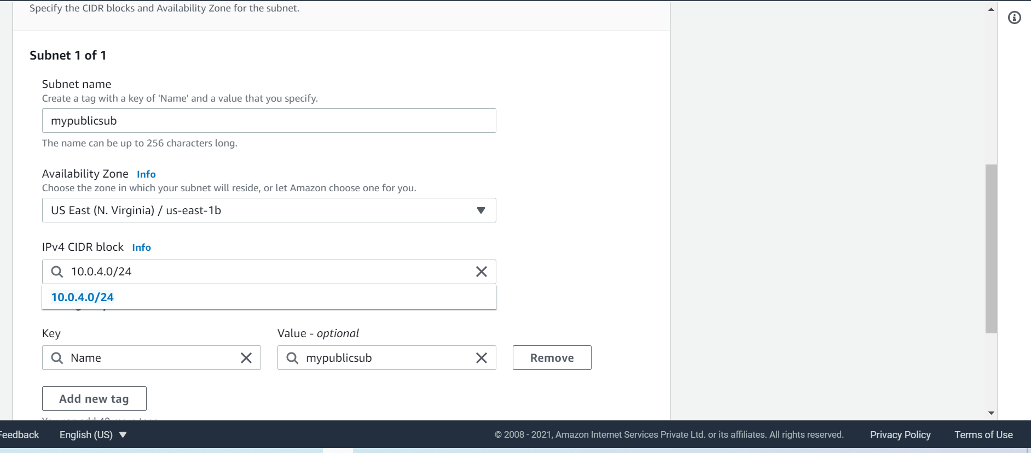

After creating the subnets we can see three public subnets created in different availability zones and in same VPC(myvpc)

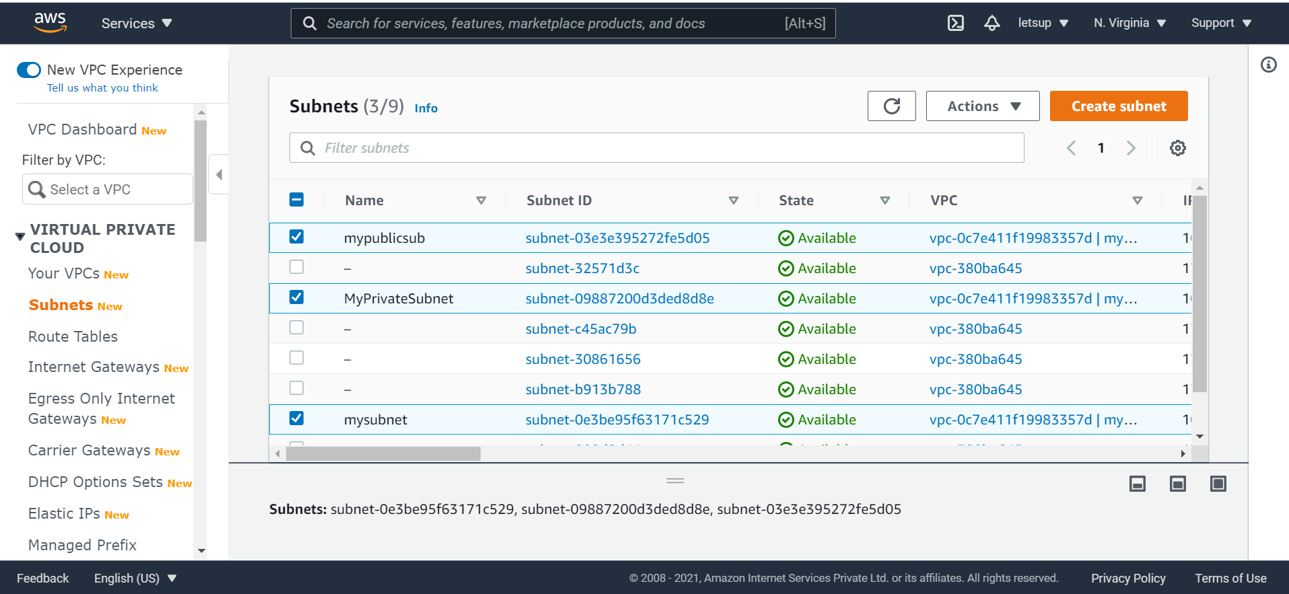

STEP 9 Creating an Application Load Balancer with multiple subnets Now we will be creating new load balancer for our webservers.

1. In the EC2 console , scroll down to Load Balancing and select Load Balancer under it.

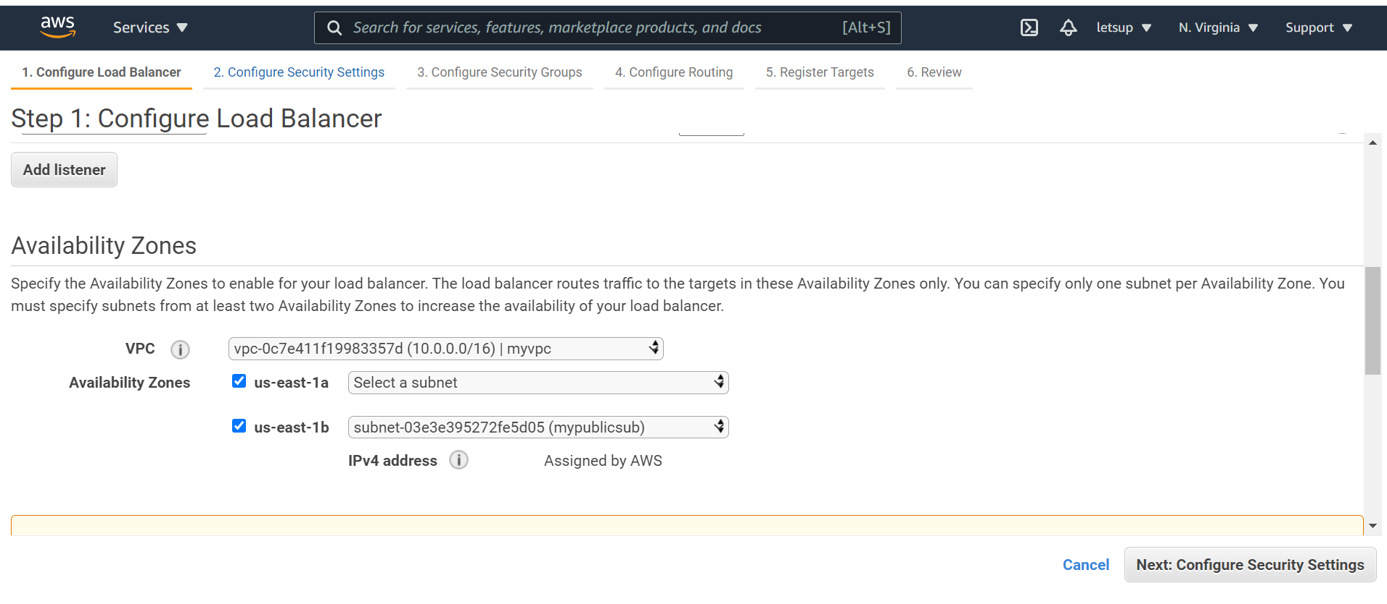

Step 12: Using load balancer DNS

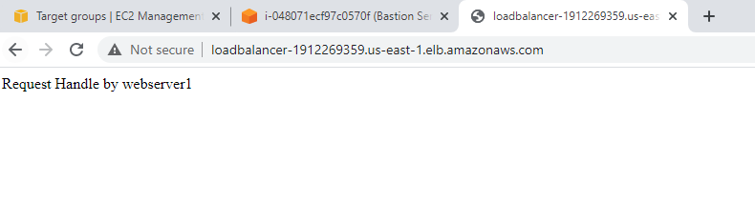

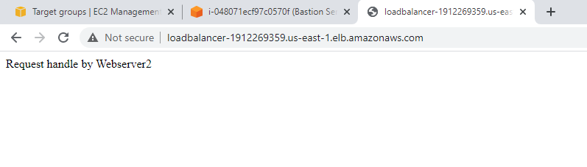

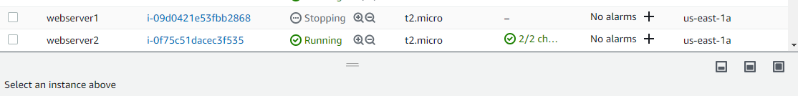

Checking High Availability

Step 13: making webserver1 down and checking with load balance DNS

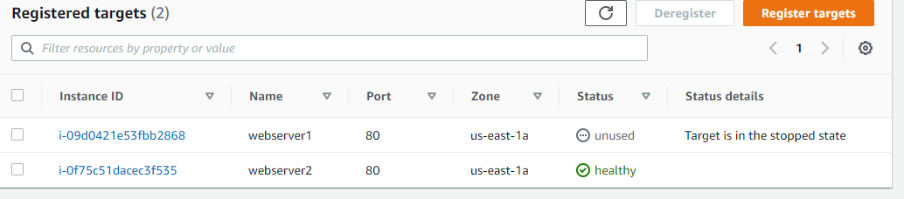

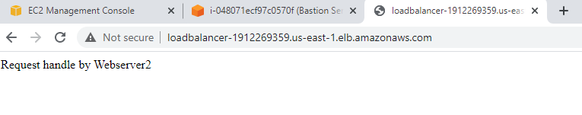

Step 14: Making webserver2 stopped and checking with Load balancer DNS

